1. Explain the advantages of Natural Queries in PowerBi with an example?

– Guided NLQ is a unique self-service BI experience

– Every question is understood by Guided NLQ

– Guided NLQ makes it simple to ask complex questions

– Guided NLQ is integrated throughout Yellowfin

– It’s easy to embed Guided NLQ into your applications

1. Explain Web Front End(WFE) cluster from Power BI Service Architecture?

The WFE cluster manages the initial connection and authentication process for Power BI, using AAD to authenticate clients and provide tokens for subsequent client connections to the Power BI service. Power BI also uses the Azure Traffic Manager (ATM) to direct user traffic to the nearest datacenter, determined by the DNS record of the client attempting to connect, for the authentication process and to download static content and files. Power BI uses the Azure Content Delivery Network (CDN) to efficiently distribute the necessary static content and files to users based on geographical locale.

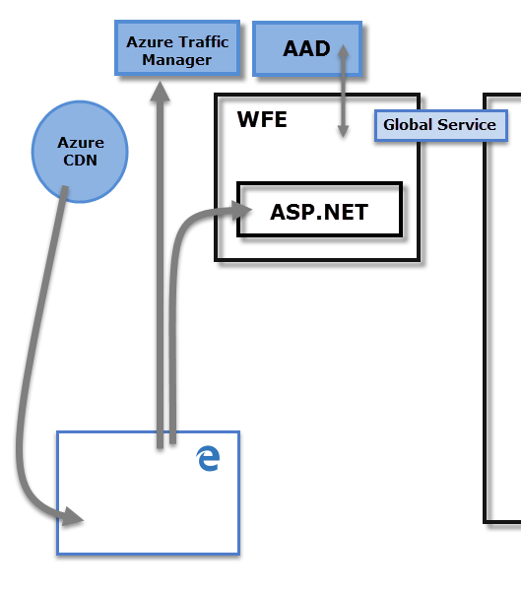

1. Explain Back End cluster from Power BI Service Architecture?

The Back-End cluster is how authenticated clients interact with the Power BI service. The Back-End cluster manages visualizations, user dashboards, datasets, reports, data storage, data connections, data refresh, and other aspects of interacting with the Power BI service. The Gateway Role acts as a gateway between user requests and the Power BI service. Users do not interact directly with any roles other than the Gateway Role. Azure API Management will eventually handle the Gateway Role.

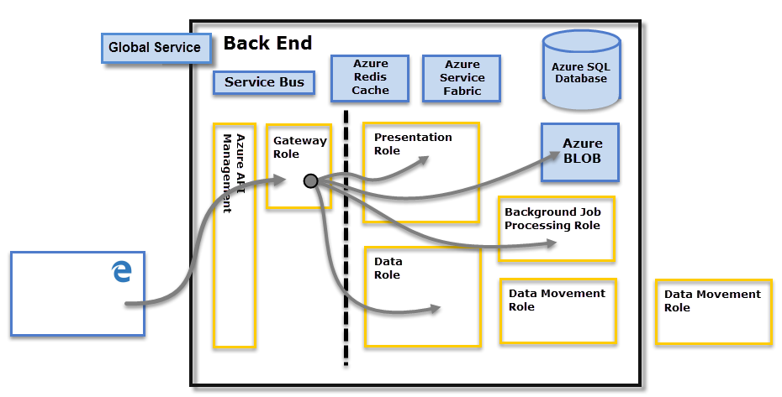

1. What ASP.NET component does in Power BI Service Architecture?

The ASP.NET component within the WFE cluster parses the token to determine which organization the user belongs to, and then consults the Power BI Global Service. The WFE specifies to the browser which back-end cluster houses the organization's tenant.

1. Compare Microsoft Excel and PowerBi Desktop

* Excel is used to organize data, transform it and perform mathematical operations and calculations. On the other hand, Power BI was conceived as a business intelligence and data visualization tool for businesses.
* Excel has limitations in the amount of data it can work with. In contrast, Power BI can handle much larger amounts of data.
* Power BI can connect to a large number of data sources, while Excel's connectivity capacity is limited. Also, unlike Excel, Power BI can be easily used from mobile devices.
* Power BI has faster processing than Excel.
* Power BI dashboards are more visually appealing, interactive and customizable than those in Excel.
* Power BI is a more powerful tool than Excel in terms of comparison between tables, reports or data files.
* Power BI is more user friendly and easy to use than Excel.

1. List 20 data sources supported by Power Bi desktop.

SQL Server database

Access database

SQL Server Analysis Services database

Oracle database

IBM Db2 database

IBM Informix database (Beta)

IBM Netezza

MySQL database

PostgreSQL database

Sybase database

Teradata database

SAP HANA database

SAP Business Warehouse Application Server

SAP Business Warehouse Message Server

Amazon Redshift

Impala

Google BigQuery

Vertica

Snowflake

Essbase

Actian (Beta)

Amazon Athena

BI Connector

Data Virtuality LDW

Denodo

Dremio Software

Dremio Cloud (Beta)

Exasol

Indexima

InterSystems IRIS (Beta)

Jethro (Beta)

Kyligence

Linkar PICK Style / MultiValue Databases (Beta)

MariaDB

MarkLogic

TIBCO(R) Data Virtualization

AtScale cubes